Day 33 - 04th Sept 2025

Task 01👍

What do you understand about DynamoDb Architecture.. ? explain using a diagram.

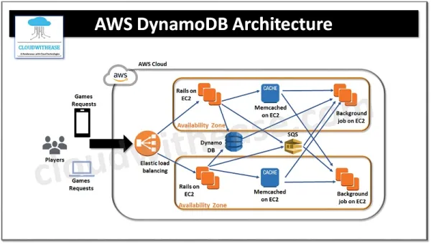

AWS DynamoDB Architecture (Explanation of the Diagram)
- Clients/Players – Users send game requests from devices.
- Elastic Load Balancer (ELB) – Distributes incoming traffic evenly across multiple servers for scalability and fault tolerance.
- DynamoDB – Acts as the main NoSQL database, storing user profiles, game state, and transactions with low latency.
- Rails on EC2 – Application servers where business logic and APIs run.
- Memcached on EC2 – Provides an in-memory caching layer to reduce DynamoDB calls and improve speed for frequent requests.
- SQS (Simple Queue Service) – Handles asynchronous communication (like queuing game events or background processing tasks).
- Background Jobs on EC2 – Processes heavy or time-consuming tasks (analytics, notifications, score updates) without affecting live requests.
- Availability Zones – Architecture is replicated across multiple zones to ensure high availability, disaster recovery, and fault tolerance.
Task 02:

What are multivalue sorts or filters..? Explain briefly..

Multi-value Sorts and Filters in DynamoDB
When you query or scan data in DynamoDB, you often want to narrow down results or sort them.
1. Multi-value Filters
- These are filters that check if an attribute contains one or more values from a list.
- Example:
  - Suppose each item has a field Tags = ["sports", "cricket", "outdoor"].
  - You can filter items where Tags contains "cricket" OR "outdoor".
- In DynamoDB, this is done using FilterExpression with functions like:
  - contains() → check if an attribute has a specific value.
  - IN → check if attribute matches any value in a list.
👉 Basically: multi-value filters help you get items that match any value from a set.

2. Multi-value Sorts
- DynamoDB doesn’t have traditional multi-column sorting like SQL, but you can achieve something similar by:
  - Composite Keys (Partition key + Sort key): You can design your table so items are ordered by the sort key.
  - When querying, you can specify:
    - BETWEEN → get items where sort key is between two values.
    - BEGINS_WITH → get items with sort key starting with certain text/pattern.
    - IN or multiple conditions to check against multiple sort key values.
- Example:
  - Table with UserID (partition key), OrderDate (sort key).
  - You can query orders between two dates, or only for certain dates.
👉 In short: multi-value sorts let you fetch items based on multiple possible values for the sort key.

Quick Example
If you have a Books table:
- Partition key: Author
- Sort key: Year
You could:
- Query all books by “Rowling” published in 2001, 2003, or 2005 → multi-value sort.
- Filter books by Rowling where Genre IN ("Fantasy", "Mystery") → multi-value filter.

Task 03:

How do you lower the cost of DynomaDB..explain ways to do so…
main strategies to reduce DynamoDB costs:

1. Choose the Right Capacity Mode
- On-Demand mode: Pay per request. Best if traffic is unpredictable or low-volume.
- Provisioned mode with Auto Scaling: Set read/write capacity and let AWS scale within limits. Better for steady workloads.
👉 Pick the right mode based on workload patterns.

2. Use Caching
- Add DynamoDB Accelerator (DAX) or Amazon ElastiCache (Redis/Memcached) to cache frequently accessed data.
- Reduces repeated reads from DynamoDB = lowers RCU (Read Capacity Unit) usage.

3. Optimize Table Design
- Use efficient partition keys → evenly distribute traffic. Prevents hot partitions that cause over-provisioning.
- Store only what you need (don’t put large blobs or unnecessary attributes). For big files, use S3 + DynamoDB metadata instead.

4. Reduce Reads and Writes
- Use BatchGetItem / BatchWriteItem instead of multiple single requests.
- Use ProjectionExpression to fetch only required attributes instead of the whole item.
- Apply filters at query time to minimize returned data.

5. Use TTL (Time-to-Live)
- Enable TTL for items that expire (like sessions, cache entries).
- Expired items are automatically deleted → saves storage cost.

6. Use Streams & Event-Driven Processing Smartly
- Be selective with DynamoDB Streams (they cost per read request).
- If you don’t need real-time events, turn them off.

7. Optimize Global Tables
- Global Tables replicate data across regions (adds cost).
- Only enabled if truly needed. Otherwise, stick to one region.

8. Monitor and Tune
- Use CloudWatch metrics to see consumed vs. provisioned capacity.
- Regularly adjust provisioned throughput.
- Use AWS Cost Explorer to analyze and spot waste.

Info box:

Excalidraw updated at 11.05

https://excalidraw.com/#json=QkKS8kaMr61IO2OuVmyy5,UGs5LYSkL0C5LM1eFOTffQ

Excalidraw updated at 13.01

https://excalidraw.com/#json=M67BNiIL9iNISXSRzaZpW,mfnzHw8ap2eEWQ57QEM0_w

Ways to reduce code - dynamodb — doc in Module 4 Dynamodb folder

https://drive.google.com/drive/folders/19jURMCjQRnl-j56VLupBhuCgkSr7oLrf?usp=sharing

Amazon AWS dynamoDb doc for reference…

https://docs.aws.amazon.com/amazondynamodb/latest/developerguide

